- 萘异氰酸酯系列(Isocyanate Series)

2,6-Diisopropylphenyl Isocyanate (DIPI)
Colorless Liquid.
CAS#: 28178-42-9
Assay: 98% min.
Package: ISO Tank.
Application: Intermediate of Polymers.
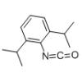

α-Naphthyl Isocyanate(NAFIK)
Appearance: Colorless Liquid.
CAS#: 86-84-0
Assay: 99% min.
Package: ISO Tank.
Application: intermediate of Pharma and Pesticide.

bis(2,6-diisopropylphenyl)carbodiimide
Appearance: White crystal particle.
CAS#: 2162-74-5
Assay: 99% min.
Package: Fiber Drum.
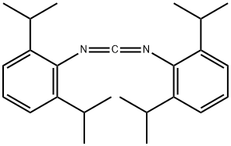

3,4-Dichlorophenyl isocyanate

Appearance: Colorless Liquid.
Assay: 99% min.
CAS#: 102-36-3
Application: Intermediate of Pharma and Pesticide.
Package: ISO Tank.
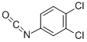

4-Isopropylphenyl isocyanate

Appearance: Oily Liquid
CAS#: 31027-31-3
ISO Tank OR 200kg Steel drum.
Application: Intermediate of Pharma. and Pesticide.
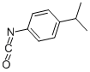

2,4,6-Triisopropylbenzol-1, 3-diisocyanate(TRIDI)

CAS#: 2162-73-4
Appearance: Colorless to light yellow liquid
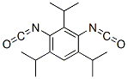

1,8-Naphthostyril
CAS#: 130-00-7
Appearance: Yellow Powder
Assay: 97% min.
Package:
Application:

N- Butyl Isocyanate(NBI)
CAS#: 111-36-4
Appearance: Colorless to light yellow liquid.
Assay: 99.0% min.
Package: 180kg/drum
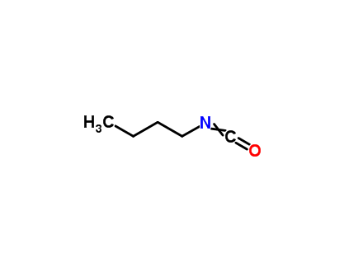

P-Phenylene diisocyanate （PPDI）
CAS#: 104-49-4
Appearance: White Flake
Assay: 99% min.
Package: steel drum.
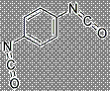

P-toluenesulfonyl isocyanate(PTSI)
CAS#: 4083-64-1
Appearance: Colorless transparent liquid
Package: 250kg/drum

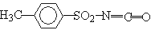

- 氨氧化系列(Benzonitrile Series)

2-Chlorobenzonitrile；873-32-5
4- Chlorobenzonitrile； 623-03-0
2,4-DiChlorobenzonitrile；6574-98-7
3,4-DiChlorobenzonitrile；64248-62-0
2,6-DiChlorobenzonitrile；1897-52-5
4-Bromobenzonitrile; 1194-02-1

- 其他产品(other Products)

Sodium Phenoxy Acetate(SPA)；
2,4-Dichlorobenzoic Acid( DCBA)；
2-Chlorobenzoic Acid (OCBA)；

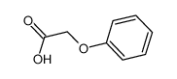

Product Name | CAS No. | Molecular Formula | Structural Formula | Application
P-toluenesulfonyl isocyanate | 4083-64-1 | C8H7NO3S | 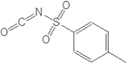 | Organic Dehydrating Agent- & Pharma Intermediate
Octadecyl isocyanate | 112-96-9 | C19H37NO | CH3-(CH2)17-NCO | Auxiliary material for wool textile softeners
P-chlorophenyl isocyanate | 104-12-1 | C7H4ClNO | 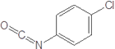 | Agro Intermediate
4-Isopropylphenyl isocyanate | 31027-31-3 | C10H11NO | 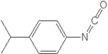 | Agro Intermediate
Octadecyl isocyanate | 34893-92-0 | C7H3Cl2NO | 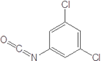 | Agro- & Pharma Intermediate
3,4-Dichlorophenyl isocyanate | 102-36-3 | C7H3Cl2NO | 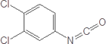 | Agro- & Pharma Intermediate

